DATA MANAGEMENT SYSTEM TO COLLECT, QUALITY CONTROL, DISTRIBUTE, AND ARCHIVE NEAR REAL-TIME MARINE DATA

Jacob T. Rettig, Mark A. Bourassa, Ph.D., Jiangyi Hu, Ph.D., E. Michael McDonald, Jeremy J. Rolph, and Shawn R. Smith
COAPS, The Florida State University, Tallahassee, FL 32306-2840
850-644-4581
jrettig@coaps.fsu.edu

ABSTRACT
The Center for Ocean-Atmospheric Prediction Studies has developed and implemented an automated data management system that collects, formats, quality controls, distributes, and archives near real-time surface marine data. The system tracks progress of the daily processing, stores metadata on instrumentation and platforms, and merges multiple daily files. All data are managed and distributed via a user friendly web interface. The application of the system to collect data from instruments deployed on research vessels and fixed towers in the Gulf of Mexico will be described.

INTRODUCTION
The Center for Ocean-Atmospheric Prediction Studies (COAPS) has developed a data management system for automated marine meteorological and near-surface oceanographic observations. Developed in 2004, the system supports underway data collection by research vessels participating in the Shipboard Automated Meteorological and Oceanographic System (SAMOS) initiative. In 2008, the system was updated to support the Northern Gulf of Mexico Institute (NGI) by providing data stewardship for instrumented Air Force towers in the northern Gulf of Mexico. The system includes (1) automated data transfer from the at-sea platform to the COAPS Data Assembly Center (DAC); (2) continuous file tracking and version control; (3) automated file formatting, metadata augmentation, and preliminary quality control (QC); (4) duplicate record elimination and merging of data from common temporal periods; (5) visual QC; (6) data distribution and archival; and (7) user discovery of desired data.

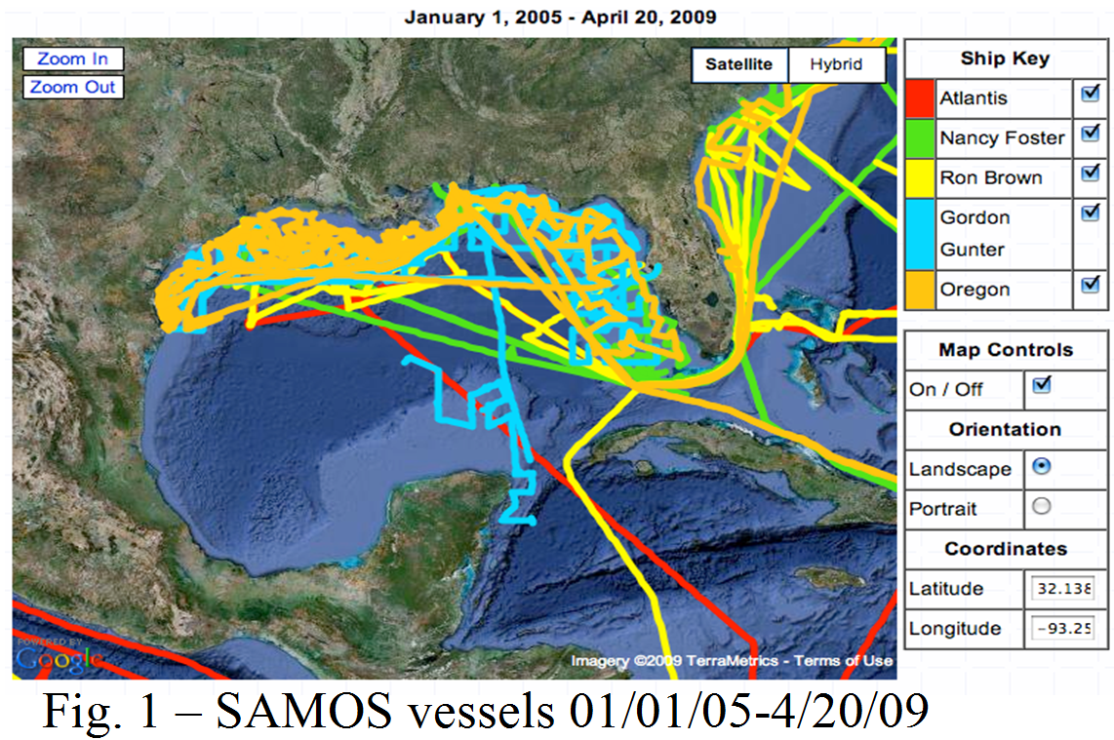
The data management system supports ongoing scientific missions of the SAMOS initiative (http://samos.coaps.fsu.edu) and NGI (http://www.coaps.fsu.edu/ngi). The SAMOS initiative manages navigational, oceanographic, and meteorological observations from 18 oceanographic research vessels, several which operate in the Gulf of Mexico (Fig. 1). SAMOS observations support validation studies for satellite sensors and numerical model products. Other applications include air-sea interaction research and developing satellite data retrieval algorithms. Meteorological observations are managed for one Air Force tower in the Northern Gulf of Mexico (29.6619º N, 84.3731º W). The data contribute to physical oceanographic, air-sea interaction, and ecosystems research (specifically the life cycle of the local grouper populations). The NGI tower data also provides real-time validation for offshore forecasts from the National Weather Service.

THE DATA MANAGEMENT SYSTEM
The data management system combines automated processing programs, a database, and web tools. Prior to processing observations, the database must be populated with platform- and instrument-specific metadata. A user friendly PHP and MySQL based web interface is used to update metadata and upload digital imagery of the instrument installation. Each incoming raw data file is broken into daily pieces and given an order number that is unique for each platform and collection date. For each order number, data files are processed through sequential automated processes via a PERL driver which queries the SQL database. Processing is tracked by giving each program’s output file a predefined version number. The file version and QC results are tracked in the database. All intermediate files and processing logs are given a naming structure that can be reproduced by the tracking information of the database. Using tracking information and filenames, web tools have been developed with PHP and MySQL to produce process tracking grids for each file with links to the files and logs, QC tables showing flag counts, vessel location history maps powered by Google Maps (Fig. 1), platform metadata accessibility, and data availability download pages.

Automated marine observations from SAMOS ships and the NGI towers follow different data transmission pathways to reach the DAC at COAPS (Fig. 2). Near 0000 UTC, a ship-specific set of one-minute interval SAMOS parameters is bundled into a daily ASCII file which is attached to an email and transmitted to shore using broadband satellite communications. In contrast, one-minute meteorological observations from the NGI tower are transmitted at ten-minute intervals to shore using line of sight radio frequency transmission. Once ashore, these data are pulled to the DAC via rsync, an open source file synchronization utility.

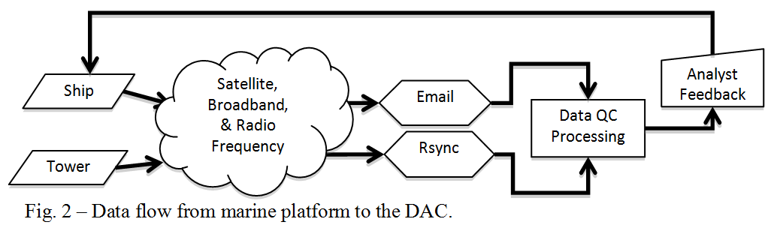

SAMOS and NGI observations undergo nearly identical processing at the DAC, with differences in the handling of SAMOS email messages versus the rsync of data files from the NGI. For SAMOS, email forwarding pushes the received email into the preliminary data processing. Preliminary processing begins with extracting each attached file from the carrier email. For NGI, an automated script run via cron, transfers files to the DAC and copies new files to an “unprocessed” directory. Each new file is pushed into the preliminary data processing. Database queries verify that the attached data file, or unprocessed file originated from a recruited vessel/tower and is in the expected format for the vessel/tower. If the original data is verified, the preliminary processing is initiated (Fig. 3). Failures result in email notification to a data quality analyst.

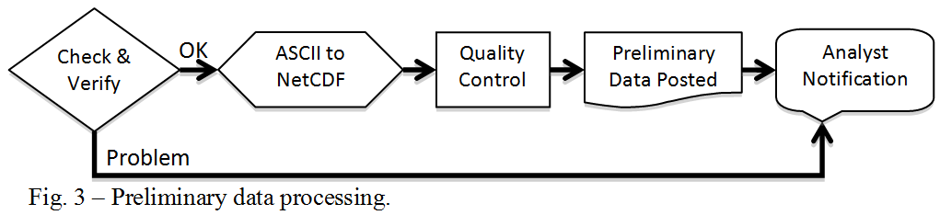

The preliminary processing automatically converts the original ASCII data to a network common data form (netCDF). The process includes converting original units to standard SI units, ensuring temporal sequence, and blending the observations with metadata from the ship profile database. Once in netCDF, the observations undergo automated QC to verify that the (1) vessel is positioned over water, (2) vessel speed between sequential positions is realistic, and (3) observations are within realistic physical limits. Some parameters (e.g., pressure, temperature, wind speed, etc.) are compared to the da Silva climatology (http://gcmd.nasa.gov/records/GCMD_NCAR_DS541.1.html) and their values are flagged when they exceed ±4 standard deviations from the climatology. Other tests ensure that the proper air, wet-bulb, and dew-point temperature relationship is not violated and the true winds are properly calculated. Once completed, QC statistics are updated in the netCDF files and the database, preliminary data are linked to distribution servers, and the analyst is notified.

A second automated process (Fig. 4) is scheduled via cron to merge all preliminary files for a given observation day, allowing for receipt of delayed or corrected files. The file merge takes into account temporal duplicates between multiple files being merged. Duplicates are resolved through a series of tests that first determine whether or not the duplicates are exact or differing. When they differ, the value with the “best” preliminary QC flag is retained. If the flags are identical, the duplicate data are compared to the 30-minute mean centered on the time in question and the value closest to the mean is retained. Failure to resolve the duplicate at this stage results in all duplicate values being removed at the time in question and details of the duplication are stored in a processing log (this is a compromise to allow for automation of the merge process).

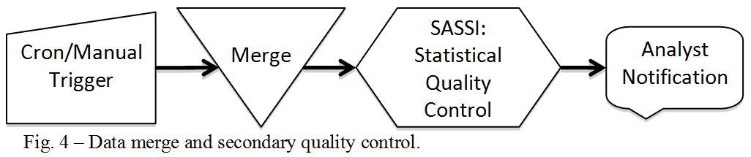

After the merge is complete, an automated Spike And Stair Step Indicator (SASSI) is run on the intermediate files to identify steps, spikes, and excessive noise in the data time series. One great advantage of this approach is that these flags tend to cluster for conditions (e.g., platform-relative wind directions) that are adversely impacted by flow distortion. The range of suspect directions can easily be determined (for each instrument) from several days of observations, allowing automatic flagging in the future. SASSI calculates the absolute value of first differences, and determines the geophysical value associated with a user defined percentile (typically the 99th percentile). A standard deviation of ‘typical’ values is based on differences less than this percentile. The threshold used for determining suspect differences in one or two time steps is equal to this standard deviation multiplied by a scale factor which is determined by an analyst. A minimum value of the threshold is set equal to the precision of the instrument; consequently, this threshold can also be used to identify periods of unrealistically low variability (e.g., a malfunctioning instrument). Mean values of unflagged observations before and after a series of flagged observations are used to determine if the flags represent a step, a spike, or excessive noise. The analyst is notified upon completion.

The NGI and SAMOS processing diverge after the intermediate files are created. Resources only allow automated processing for the NGI; however, the SAMOS observations undergo two sets of visual inspection. First, an analyst ensures that preliminary data are received in a timely manner and identifies gross malfunctions and problems. When issues arise, the analyst promptly notifies the vessel at sea (Fig. 2). This feedback benefits the shipboard technicians and often results in quick repairs to systems. Second, the analyst uses the SAMOS VIsual Data Assessment Tool (SVIDAT) - a graphical user interface developed by the DAC using the Interactive Data Language - to verify all automated QC and to add/delete/modify QC flags. Visual quality evaluation results in research quality files which are nominally produced on a 10-day delay once the intermediate files are available. In practice, this delay can be longer due to resource and time limitations of the data quality analysts.

All preliminary, intermediate, and research quality data are distributed via web (http://samos.coaps.fsu.edu), FTP, and THREDDS services. Archival is ensured via the Ocean Archive System (OAS) at the U.S. NODC.

LOOK FORWARD
Quality-evaluated marine observations from SAMOS vessels and the NGI towers will be provided to the Integrated Oceanographic Observing Systems Regional Associations (e.g., GCOOS, SECOORA) to support a wide range of NOAA activities. Presently, only one NGI tower is instrumented, but plans are in place to expand by 1-2 additional towers in 2010. A subsurface cable will be deployed at the first NGI tower in the summer of 2009 to facilitate real-time transmission of sub-surface and ocean bottom measurements. As funds allow, the COAPS data management system will evolve to include new QC techniques and processing for additional oceanographic parameters.

